Internal Quarterly Report

Date of Report: 9th Quarterly Report- December 24, 2024
Contract Number: 693JK32210002POTA
Prepared for: Government Agency: DOT and Co-funders
Project Title: Monitoring the Long-Term Compatibility of Vapor Corrosion Inhibitor and Cathodic Protection Associated Components
Prepared by: Pipeline Research Council International, Inc.
Contact Information: Janie Norton, email: jnorton@prci.org
For quarterly period ending: December 31, 2024

1: Items Completed During this Quarterly Period:

Item # | Task # | Activity/Deliverable | Title | Federal Cost | Cost Share
27 | 3 | Finish VCI compatibility with non-sand pad materials laboratory test, analyze data and draw conclusions | Summary of the data to be included in the quarterly report | $9,773 | $9,773
31 | 2 | Monitor progress of various field testing | Summary of the progress to be included in quarterly report | $6,515 | $6,515
32 | 5 | Quarterly status report & project management | Submit 9th quarterly report | $4,364 | $4,364

2: Items Not Completed During this Quarterly Period:

Item # | Task # | Activity/Deliverable | Title | Federal Cost | Cost Share
30 | 2 | Finish large-scale control experiments to determine VCI dispersion range, collect and analyze data | Summary of the data to be included in the quarterly report | $19,545 | $19,545

3: Project Financial Tracking During this Quarterly Period:

Note that this chart reflects Federal share only.
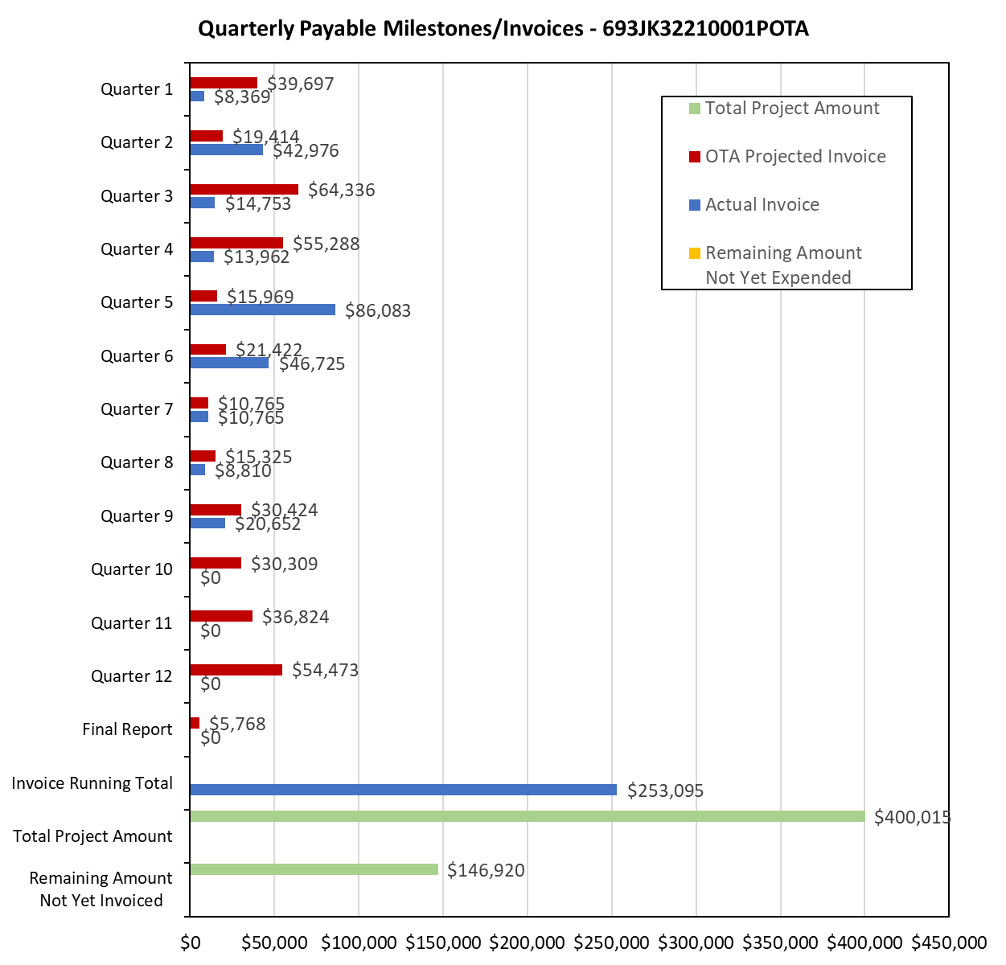

4: Project Technical Status:

Item 27, Task 3 ⎯ Finish VCI compatibility with non-sand pad materials laboratory test, analyze data and draw conclusions. Summary of the data to be included in the quarterly report: the various experiments were started toward the end of 6th quarter. The coupons in the various experiments have finished 6-month exposure. Summary of the experimental data and results are following:
- Experiment 1: the control experiment without VCI, the chloride level was 30 ppm. The coupons corrosion rates were in the range of 3-9 mpy.
- Experiment 2: the control experiment with a VCI applied throughout the experimental surface, the chloride level was 30 ppm. The coupons corrosion rates were negligible.
- Experiment 3: half of the surface area of the experiment was treated with the VCI and remaining half was not treated, the chloride level was 30 ppm. The coupons corrosion rate with VCI treatment was negligible. The coupons corrosion rates in the area without VCI treatment ranged between 1-3 mpy. The coupon data indicate that VCI migrated from the VCI treated area to the non-treated area. The amount of VCI used in Experiments 2 and 3 was same.

The overall experimental data showed that the VCI applied in the powder form on a concrete pad can migrate from the VCI treated area to the non-treated area and mitigate corrosion of the tank bottom areas where powder application did not result in VCI delivery. The experimental data also indicated that VCI delivery on a concrete pad should be engineered such that the inhibitors are delivered to maximal possible extent covering throughout the tank bottom. This will ensure that any pockets of tank bottom not receiving the VCIs are minimum.

This activity links to item 10 in Attachment 1 Team Project Activities. This activity also satisfies item 17 in Attachment 2 Project Deliverables.

Item 31, Task 2 ⎯ Monitor progress of the various field testing. Summary of the progress to be included in quarterly report: The field testing for the VCI-treated tanks and recently-VCI-treated tanks was started in the 5th quarter. The monitoring data for two quarters have been collected for those tanks. The field sand samples from the previously treated VCI tanks have been received and analyzed. The field sand samples from the recently-treated-with-VCI tanks have also been received and have been analyzed. The mass-loss coupons that were placed under some of the VCI treated tanks were removed. The mass-loss coupons have been analyzed. In addition, the monitoring data for electrical resistance (ER) and UT probes were collected during the seventh quarter; the eight quarter readings were collected in October 2024, and the ninth quarter reading will be collected towards the end of December 2024. The eight-quarter field data collection was delayed due to scheduling and maintenance issues at the field-testing terminals. This activity links to items 6 and 7 as listed in Attachment 1 Team Project Activities. This activity also satisfies item 20 in Attachment 2 Project Deliverables.

Item 32, Task 5 ⎯ Quarterly status report & project management. Submit 9th quarterly report: The 9th quarter project meeting was held on December 4, 2024. This item has been completed, and it partly satisfies item 25 in Attachment 2 Project Deliverables. It also links to item 13 as listed in Attachment 1 Team Project Activities. The quarterly meeting link to item 11 as listed in Attachment 1 Team Project Activities.

5: Project Schedule:

Item 30, Task 2 ⎯ Finish large-scale control experiments to determine VCI dispersion range, collect and analyze data. Summary of the data to be included in the quarterly report: The large-scale experiments are still ongoing and will be finished in the next quarter. The post-VCI treated coupons will be extracted and analyzed.

Overall, the project is a bit behind schedule, but activities will catch up in the next quarter.

